
AI-Powered Legal Document Generator
Phase 04:
Project Planning

AI-generated template, not legal advice; have a lawyer review.

Table of Contents
1. Planning Approach 2
2. Task Schedule 2
3. Gantt Chart 3
4. Timeline and Weekly Deliverables 3
5. Risk Register 3
6. Tools and Resources 4

1. Planning Approach
The project was planned as four one-week iterations that follow the six milestones of the project brief: M1 model selection and environment, M2 core generation and export, M3 API, M4 user interface, M5 deployment scripts and M6 end-to-end testing. Must-have features were scheduled first so that a working product existed by the end of week 3. Dates below are the planned schedule; the Status column shows the state of each deliverable on 25 September 2026 (Done = present in the repository and verified by running it).

2. Task Schedule
Table 1: Task list with owner, planned dates, duration (working days) and status
ID | Task | Owner | Start | End | Days | Status
T01 | Brainstorming and idea selection | Intern | 31 Aug | 01 Sep | 2 | Done
T02 | Requirement analysis (FR, NFR, user stories) | Intern | 01 Sep | 03 Sep | 3 | Done
T03 | M1: Model selection and dev environment | Intern | 03 Sep | 04 Sep | 2 | Done
T04 | System design: architecture, DFD, prompts | Intern | 07 Sep | 08 Sep | 2 | Done
T05 | M2: Core generation (Gemini + offline templates) | Intern | 08 Sep | 10 Sep | 3 | Done
T06 | M2: Export utilities (TXT, DOCX, PDF) | Intern | 10 Sep | 11 Sep | 2 | Done
T07 | M3: FastAPI backend (/, /health, /generate) | Intern | 14 Sep | 15 Sep | 2 | Done
T08 | M4: Streamlit UI (form, preview, editor, downloads) | Intern | 15 Sep | 17 Sep | 3 | Done
T09 | Demo mode, AI fallback and error handling | Intern | 17 Sep | 18 Sep | 2 | Done
T10 | M6: Automated tests (pytest) and UI checks | Intern | 21 Sep | 22 Sep | 2 | Done
T11 | M5: Deployment scripts (run.sh, run.bat) | Intern | 22 Sep | 22 Sep | 1 | Done
T12 | Screenshots, demo and testing videos | Intern | 23 Sep | 23 Sep | 1 | Done
T13 | Documentation, final report and presentation | Intern | 23 Sep | 25 Sep | 3 | Done
T14 | Mentor review of report and slides | Mentor | 25 Sep | 25 Sep | 1 | Planned
T15 | Final demonstration and viva | Intern + Mentor | 28 Sep | 28 Sep | 1 | Planned

3. Gantt Chart
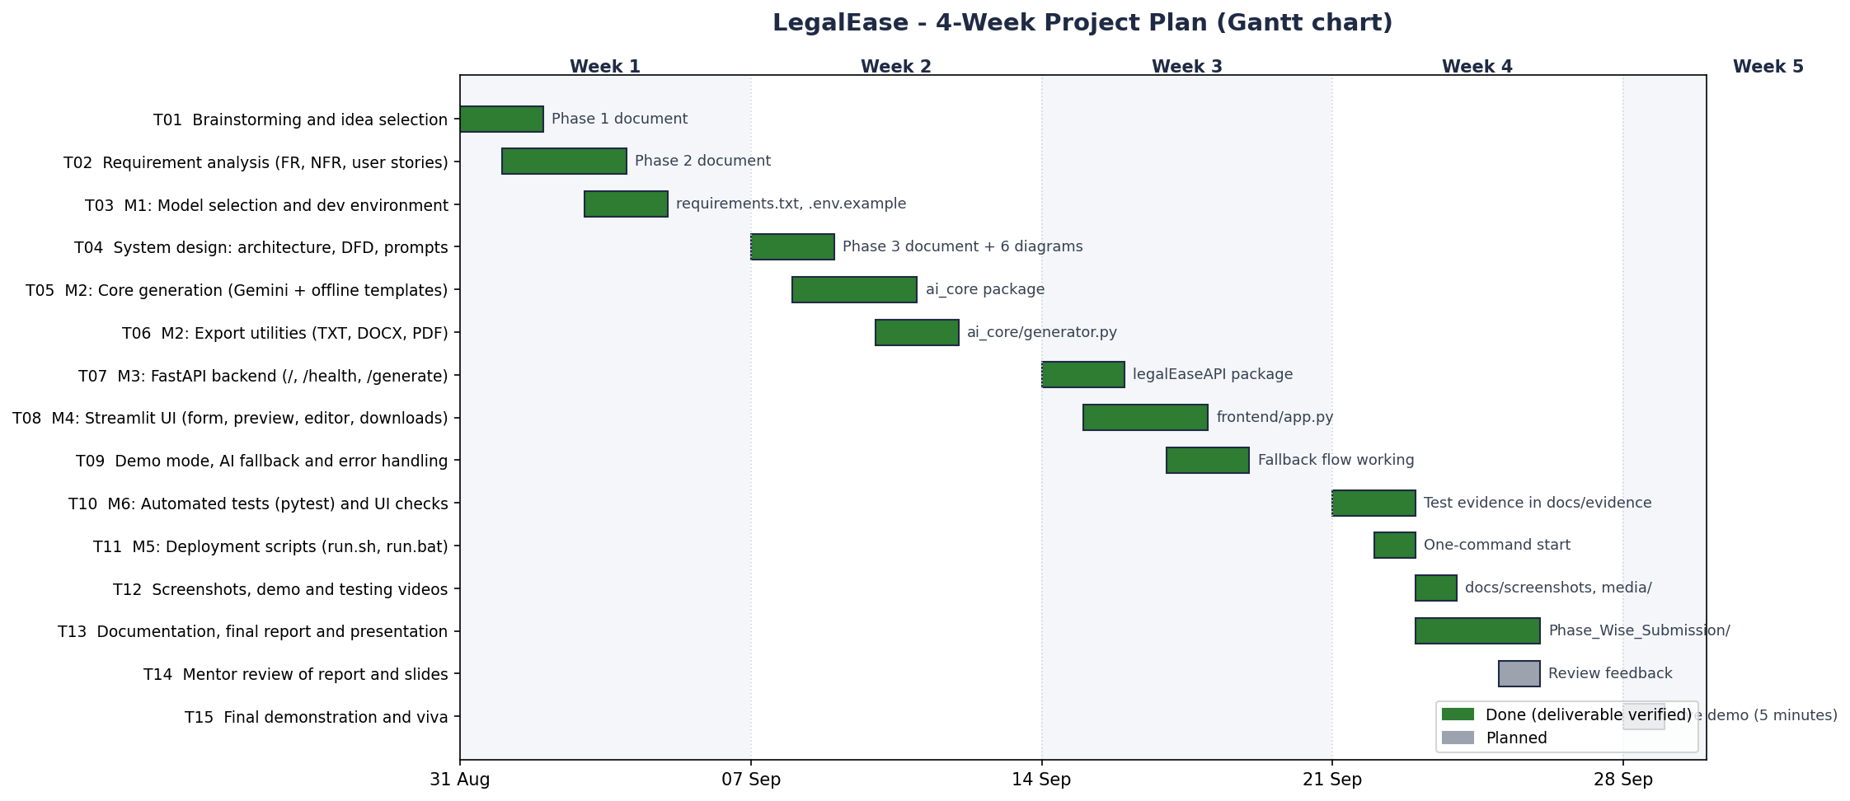
Figure 1: Gantt chart of the 4-week plan
Gantt_Chart.xlsx contains the same plan with a visual bar column, a day-by-day coloured grid, a native Excel stacked-bar chart, the weekly deliverables and the risk register.

4. Timeline and Weekly Deliverables
Table 2: Weekly deliverables
Week | Focus | Deliverables
Week 1 (31 Aug - 4 Sep) | Idea, requirements and setup | Problem statement, personas, idea comparison, FR/NFR list, user stories, Python environment and model choice.
Week 2 (7 - 11 Sep) | Design and core engine | Architecture, DFD, use case and flow diagrams; prompt design; ai_core generation and TXT/DOCX/PDF export.
Week 3 (14 - 18 Sep) | API and user interface | FastAPI routes with Pydantic validation; Streamlit form, preview, editor and downloads; Demo mode and fallback.
Week 4 (21 - 25 Sep) | Testing and documentation | pytest suite with coverage, UI edge-case checks, screenshots, videos, phase documents, report and slides.

5. Risk Register
Table 3: Risk register (L = likelihood, I = impact: H/M/L)
ID | Risk | L | I | Mitigation | Status
R1 | Gemini API key unavailable or free quota exhausted | H | H | Demo mode (offline templates) and automatic fallback with a clear message | Mitigated
R2 | Model retired or renamed (the spec used gemini-1.5-pro) | H | H | Model ID read from GEMINI_MODEL in .env; default gemini-3.8-flash | Mitigated
R3 | AI output inaccurate, incomplete or badly structured | M | H | Structured prompt, output validation, disclaimer, lawyer review | Mitigated
R4 | Prompt injection or HTML injection through user input | M | M | Inputs wrapped in <<< >>> delimiters; HTML escaped in the preview | Mitigated
R5 | Unicode (₹, curly quotes) breaks PDF export | M | M | fpdf2 with bundled DejaVu fonts; automated Unicode tests | Mitigated
R6 | Exports ignore the user's edits (bug in the spec code) | H | H | current_export_text() used for preview and all downloads; tested | Fixed
R7 | Backend not running during the demo | M | M | run.sh / run.bat start both servers; friendly UI error; demo checklist | Mitigated
R8 | Schedule slip in week 3 or 4 | M | M | Must-have features first; weekly deliverables; nice-to-have items can move | Closed

6. Tools and Resources
Table 4: Tools and resources
Tool | Used for
Python 3.13.14, VS Code, Git | Programming, editing and version control
FastAPI 0.141.1, Uvicorn 0.54.0, Pydantic 2.13.4 | Backend API and validation
Streamlit 1.64.0 | Frontend user interface
google-genai 2.25.0 | Google Gemini API access (model from GEMINI_MODEL)
python-docx 1.1.2, fpdf2 2.8.8, Pillow 12.3.0 | DOCX, PDF and image handling
pytest 9.0.3, pytest-cov 7.1.0, Playwright 1.63.0 | Automated tests, coverage, screenshots, UI checks and videos
LibreOffice, pdf2image, ffmpeg, Graphviz, matplotlib | Rendering exports, videos and diagrams
openpyxl 3.1.5, python-pptx 1.0.2 | Excel sheets and the presentation

